**Module 2 Assignment: JavaScript language**

Sushmita Prafull Halasawade

IFT 544: Middleware Prog & Database Sec

Dinesh Sthapit

3 Sep 2023

**Javascript introduction:**

**Javascript Function refactoring:**

**JavaScript Refactoring 3:**

**Javascript variables:**

Javascript Objects 5 :

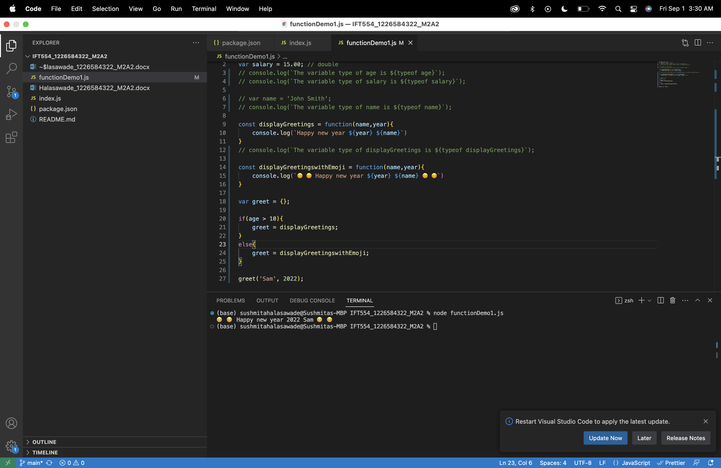

JavaScript Parameter (Function as a parameter)

JavaScript Master Document Reference (required) 7:

JavaScript Objects:

JavaScript Arrays 9:

JavaScript Accessing Elements of JavaScript Object Arrays 10:

